Steps for auto Django attendance project
Step 1:
If python is not downloaded
Install python by https://www.python.org/downloads/
Step 2:
Go to directory where your file is located and then in address bar write cmd
(you must sure that cmd is open in your project directory )
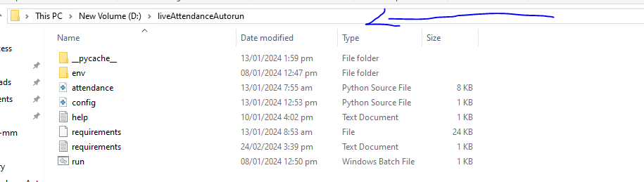
Step 3:
Write this command.
pip install -r requirements.txt
(This command automatically downloads your required packages)

Step4:
Write this command.
Python attendance.py
Or just click on run.bat file.
if you face some error then check help.txt

make an exe file for this.
Step 1
pip install auto-py-to-exe
step 2:
auto-py-to-exe

select a folder where your file is located then select
attendance.py file

